KJSCE/IT/TYBTECH /SEM-VI/CC/2021-22

**Experiment No.: 01** 

**Title: VMWare Workstation Installation and Configuration**

(Autonomous College Affiliated to University of Mumbai)

KJSCE/IT/TYBTECH /SEM-VI/CC/2021-22

**Batch: A4 Roll No.: 1914078 Experiment No.:1**

**Aim:** VMware workstation installation and configuration

**Resources needed:** VMWare Setup

**Pre Requisite:** Understanding of Installation of Operating System

**Theory:** 

Concept of Virtualization

Virtualization addresses IT’s most pressing challenge: the infrastructure sprawl that compels IT departments to channel 70 percent of their budget into maintenance, leaving scant resources for business-building innovation.

The difficulty stems from the architecture of today’s X86 computers: they’re designed to run just one operating system and application at a time. As a result, even small data centers have to deploy many servers, each operating at just five percent to 15 percent of capacity—highly inefficient by any standard.

Virtualization software solves the problem by enabling several operating systems and applications to run on one physical server or “host.” Each self-contained “virtual machine” is isolated from the others, and uses as much of the host’s computing resources as it requires.

Advantages of virtualization

∙ Run multiple operation systems on one server. For example, instead of having development-server and QA-server, you can run both development and QA on a single server.

∙ You can have multiple flavours of OS on one server. For example, you can run 2 Linux OS, 1 Windows OS on a single server.

∙ Multiple OS running on the server shares the hardware resources among them. For example, CPU, RAM, network devices are shared among development-server and QA-server running on the same hardware.

∙ Allocate hardware resources to different applications based on the utilization. For example, if you have 8GB of RAM on the server, you can assign less RAM to one virtual machine (2GB to development-server) and more RAM (6GB to QA-server) to another virtual machine that is running on that server

(Autonomous College Affiliated to University of Mumbai)

KJSCE/IT/TYBTECH /SEM-VI/CC/2021-22

∙ High availability and business continuity. If VMware is implemented properly, you can migrate a virtual machine from one server to another server quickly without any downtime.

∙ This reduces the operational cost and power consumption. For example, instead of buying and running two servers, you will be using only one server and run both development and QA on it.

VMware

VMware is a virtualization and cloud computing software provider for x86-compatible computers. VMware Inc. is a subsidiary of EMC Corporation and has its headquarters in Palo Alto, California. VMware Workstation makes it possible to partition a single physical server into multiple virtual machines. VMware workstation works with Windows, Solaris, Linux and Netware, any or all of which can be used concurrently on the same hardware.

**Procedure:**

1. Download VMWare workstation from

**https://www.vmware.com/in/download/open_source.html**

2. Download the s e t u p file and run the executable when the download is completed. When the download is completed, click **Run** again and the executable will start the VMware Installation Wizard.

3. Install VMware Server and Crate Virtual machine.

**Results: (Steps with screenshots)**

* On VMWare workstation player, click on create a new virtual machine

# 

# Choose the third option and click on next

# 

# Choose Linux as operating system because we are going to be using Ubuntu 64-bit

# 

# Name the virtual machine and change location to desired, and then click next

# 

# Now, specify Disk Capacity. Here, we would be setting it as 100 GB and choose the option to split virtual disk into multiple files. Click on Next.

# 

# Click on customize hardware to make changes. Change memory to 8 GB, processor core can be changed to 4 and so on.

# 

# Move to new CD/DVD and click on the option to choose iso file. Browse for the location of your iso file wherever it has been downloaded and then click on close.

# 

# On clicking on Finish, we see that the Ubuntu Virtual Machine has been created. Select the Ubuntu machine and then click on play virtual machine

# 

# On doing that, we see a software update window. Click on download and install

# 

# We see a welcome screen. Select your preferred language and click on install Ubuntu.

# Choose your preferred keyboard layout and click on continue.

# In the next window, we see updates and software. Leave it as default and in addition, check the checkbox that says install third-party software

# 

# Now choose a location nearer to your physical location and click on continue.

# 

# Give your Ubuntu operating system and your computer a name. Set username and password and click on continue

# At this the installation of Ubuntu on the VMware player will get started.

# 

# When the installation is completed, we see a message pop up as below. Restart the ubuntu operating system in order to use the new installation system.

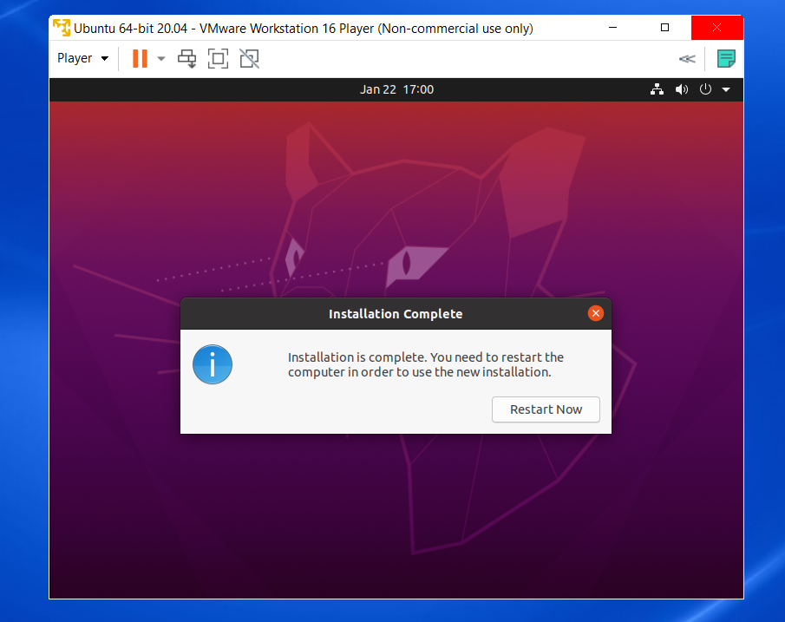

Ubuntu will ask you to enter credentials to login.

Once done, it will ask you to connect using any account which you can skip.

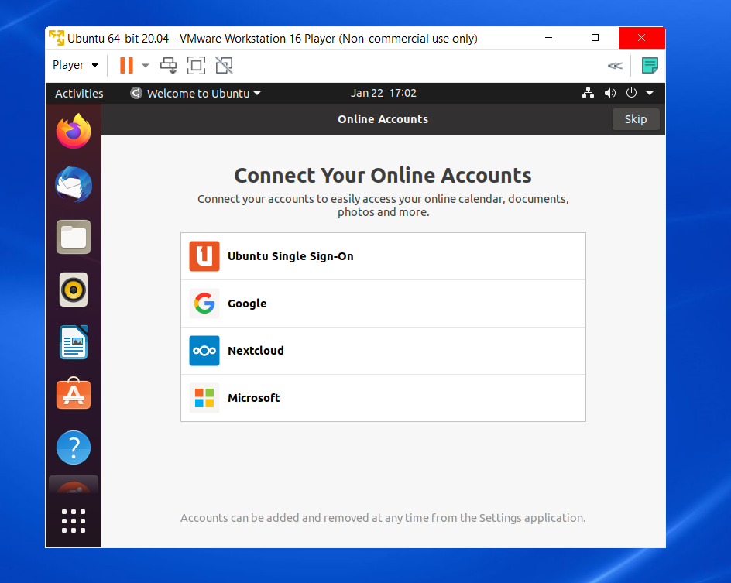

# Our installation is now complete and we are ready to use the Ubuntu 20.04 LTS version on our VMware player on the Windows operating system.

**Questions:**

1. On a particular server, within each virtual machine:

a. You can run any version of Windows without regard for the version(s) running in the other virtual machines.

b. The versions of Windows must be no more than one release level apart c. The versions of Windows must be the exactly same.

2. On a particular server:

a. If you need to reboot one virtual machine, you have to first reboot the physical server, the individual virtual machines and then reboot automatically when the physical-machine reboot is finished.

b. If you reboot one virtual machine, all the other virtual machines reboot at the same time.

c. You can reboot a virtual machine without it having any effect on the other virtual machines.

3. When choosing which applications or databases to place on one physical machine (using a virtual machine for each application), it is best to:

a. Choose a mixture of applications and databases with different workloads.

b. Keep all the heavy-workload application/databases together and all the light workload applications and databases together.

(Autonomous College Affiliated to University of Mumbai)

KJSCE/IT/TYBTECH /SEM-VI/CC/2021-22

4. Introduction of server virtualization in a data center:

a. Will make the introduction of Storage –Area Network (SAN) absolutely necessary.

b. Will make the introduction of Storage –Area Network (SAN) desirable. c. Will not materially change storage requirements.

5. In a virtualized- server environment, compared with a traditional server environment: a. It is easier to keep track of software licensing.

b. Tracking software licensing is neither materially easier nor harder.

c. It is significantly harder to keep track of software licensing.

6. The VM Kernel can't boot it by itself, so that it takes the help of the 3rd party operating system.

a. True

b. False

7. List the major components of Vmware Infrastructure?

The major components of VMware infrastructure are:

* Web Browser
* ESX server host
* Database
* Virtual Centre Server
* License Server
* Virtual Infrastructure (VI) client

**Outcomes:**

CO1: Understand Virtualization

**Conclusion: (Conclusion to be based on the objectives and outcomes achieved)**

During the course of this experiment, we understood virtualization and installed Ubuntu LTS operating system on the VMware workstation player.

**Grade AA/ AB / BB / BC / CC / CD /DD**

**Signature of faculty in-charge with date**

**References:**

**Books/ Journals/ Websites:**

1. http://www.vmware.com/in

(Autonomous College Affiliated to University of Mumbai)